Titulo de Tese

# 1 Artigo Tese

## 1.1 Methods

### 1.1.1 Study site

Field work was conducted at one site located approximately 5km away from the village of Anillaco, in the province of La Rioja, northwest of Argentina. The study site (-66.95°, -028.80, 1325m; Fig. 1.1) is a relatively undisturbed natural area - with little human disturbance and no artificial light source - surrounded by the Sierra de Velasco moutain range, located within the Monte Desert biome. The Monte Desert is characterized as an open shrubland dominated by Zygophyllaceae (*Larrea cuneifolia* Cav., *Tricomaria usillo*), Fabaceae (*Prosopis torquata*, *Senna aphylla*) and Cactaceae (*Trichocereus* spp, *Tephrocactus* spp) (Abraham et al. 2009; Aranda-Rickert, Diez, and Marazzi 2014; Fracchia et al. 2011). At the study site a non-extensive survey of the plant community divided in three transects showed a dominance of the families Zygophyllaceae (*Larrea cuneifolia*, *Tricomaria usillo*), Poaceae (*Microchloa indica*, *Aristida mendocina*) and Fabaceae (*Zuccagnia punctata*) (see Appendix). The climate is arid with marked daily cycle and seasonality in temperature and rainfall (see Appendix). The mean annual temperature is 16.6°C (Fracchia et al. 2011), with clear differences in the daily range and between summer and winter months (Abraham et al. 2009). The mean annual rainfall ranges from 145 to 380mm concentrated almost exclusively in the summer months (Fracchia et al. 2011).

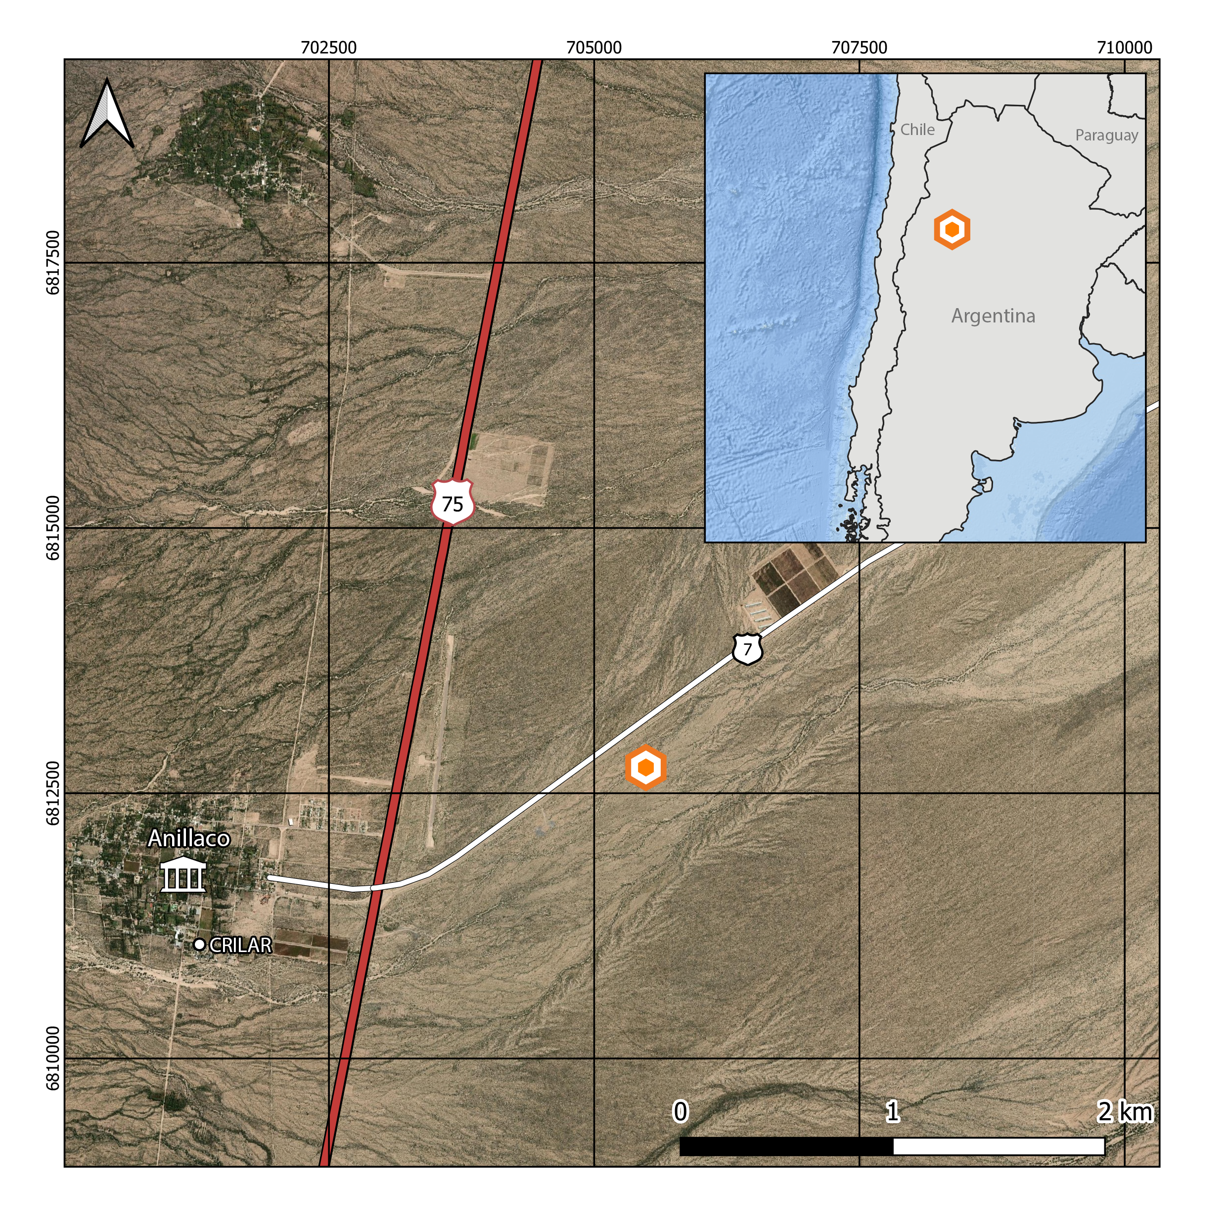

Figure 1.1: Study site location (orange icon) at the Monte Desert, approximately 5km away form the village of Anillaco, northwest of Argentina

### 1.1.2 Study species

The studied *Ctenomys* population lacks a formal phylogenetic and taxonomic classification but there are some lines of evidence suggesting that the study area is occupied by a single unidentified species (REF Amaya form and function). In other studies this Ctenomys’ species has been referred informally as the Anillaco tuco-tuco (REF Amaya) and as *Ctenomys aff. knightii* (REF) or *Ctenomys cf. knightii* (REF).

### 1.1.3 Capture and Recapture

Tucos were captured by searching the study area for fresh signs of burrow entrances. Once found, custom made traps, similar in functionality to a Shermann trap, were placed at the burrow’s entrance. Our custom made traps were made out of PVC tubing (35cm length, 10cm diameter) with a spring-loaded aluminum door at one and a cul-de-sac at the other. The traps were placed in the field during the morning and checked every hour until the beginning of the night, when they were taken out.

After being captured, adult tucos (>120g) were first anesthetized in order to be carefully examined and receive a collar with activity sensors. We used a clear plastic anesthesia chamber (volume?) with a clip-on lid and a cotton ball inside. We added approximately 0.5 mL of isoflurane (REF) to the cotton ball before transferring the animal from the trap to the plastic anesthesia chamber. While in the chamber tucos were observed for breathing, blinking and loss of righting reflex. Once the tucos could not right themselves they were removed from the chamber. Out of the chamber anesthetezied animals were weighted, sexed, marked with a subcutaneous identification PIT Tag (Passive Integrative Transponder. Allflex, Brasil) and received a collar with activity sensors and a telemetry transmitter (SOM-2011. Wildlife Materials, Illinois, USA). Tucos were them placed back in the trap and observed until fully recovered. Once recovered tucos were transported and released in the same burrow they were captured. Marked animals were left in the field for 5-10 days before being recaptured. The telemetry transmitter were used to maximize the animals relocation and recapture, avoiding the loss the other devices.

* apendice:
  + fotos da armadilha ?
  + foto do colar ?

### 1.1.4 Activity data

The accelerometers attached to the animal’s collar were configured to record at a 10 Hz sampling frequency with a 4G sensitivity. The lightloggers were set to record at a sample each 5 minutes with range of sensitivity from 0.3 to 19000 lux.

* The data collection were done The recaptures were done with the to the
* Accelerometers are devices that continuously record the animal’s movement in a three axis orthogonal system with a high sampling frequency (REF).
* a lightlogger (Migrate Technology, Cambridge, UK), a accelerometer (Axy3. Technosmart, Rome, Italy)
* acelerometros
* luximetros
* radiotelemetria
* armadilhas
* permissoes

Vectorial Dynamic Body Acceleration (VeDBA, Qasem et al. 2012) was used as a proxy for the animal’s activity level. VeDBA was calculated by: (i) Estimating the effect of the gravitational force over the accelerometer, also known as static acceleration. The static acceleration can be estimated by applying a moving average over the raw acceleration data. There is not a consensus over the the number of points to calculate the moving average with, which can be dependent on the study species and device’s recording frequency (REF??). Generally, a 1 or 2-second moving average is used to calculated the static acceleration (REF??). However, in the case of the tucos we opted to use a 4-second moving average (40 data points) after following the method proposed by (Shepard et al. 2008, see Appendix). (ii) Calculating the acceleration correspondent to the animal’s movement, also know as Dynamic Body Acceleration (DBA). The DBA was calculated by subtracting the static acceleration from the raw data. (iii) Lastly, we calculate the VeDBA by the vectorial sum of the DBA over the device’s axis, using:

$$VeDBA=\sqrt{Xd^{2}+Yd^{2}+Zd^{2}}$$

# (APPENDIX) Appendix

# Appendix

# 2 Anillaco’s Plant Community

Following methods similar to Aranda-Rickert, Diez, and Marazzi (2014) a non-extensive survey of the plant community was done in May 2019. Three perpendicular 50m transects were defined near the study site (COORDINATES). A point-intercept method was used to record plant species present in the transects, species right below the sampling points were registered in the data. Sampling points were defined every 1m along the 50m transects. Plant species were identified in the field by a Botanist, except for a few members of the Poaceae family.

The results for the plant survey is in line with what has been described in the literature for the region (Abraham et al. 2009; Aranda-Rickert, Diez, and Marazzi 2014; Fracchia et al. 2011). The results show a dominance of Zygolhyllaceae, Poaceae and Fabaceae families. The relative frequency of plant families and species recorded in the area are shown in the graphs below (Fig. 2.1).

include_graphics("../05_figures/plants/plant_frequency.png")

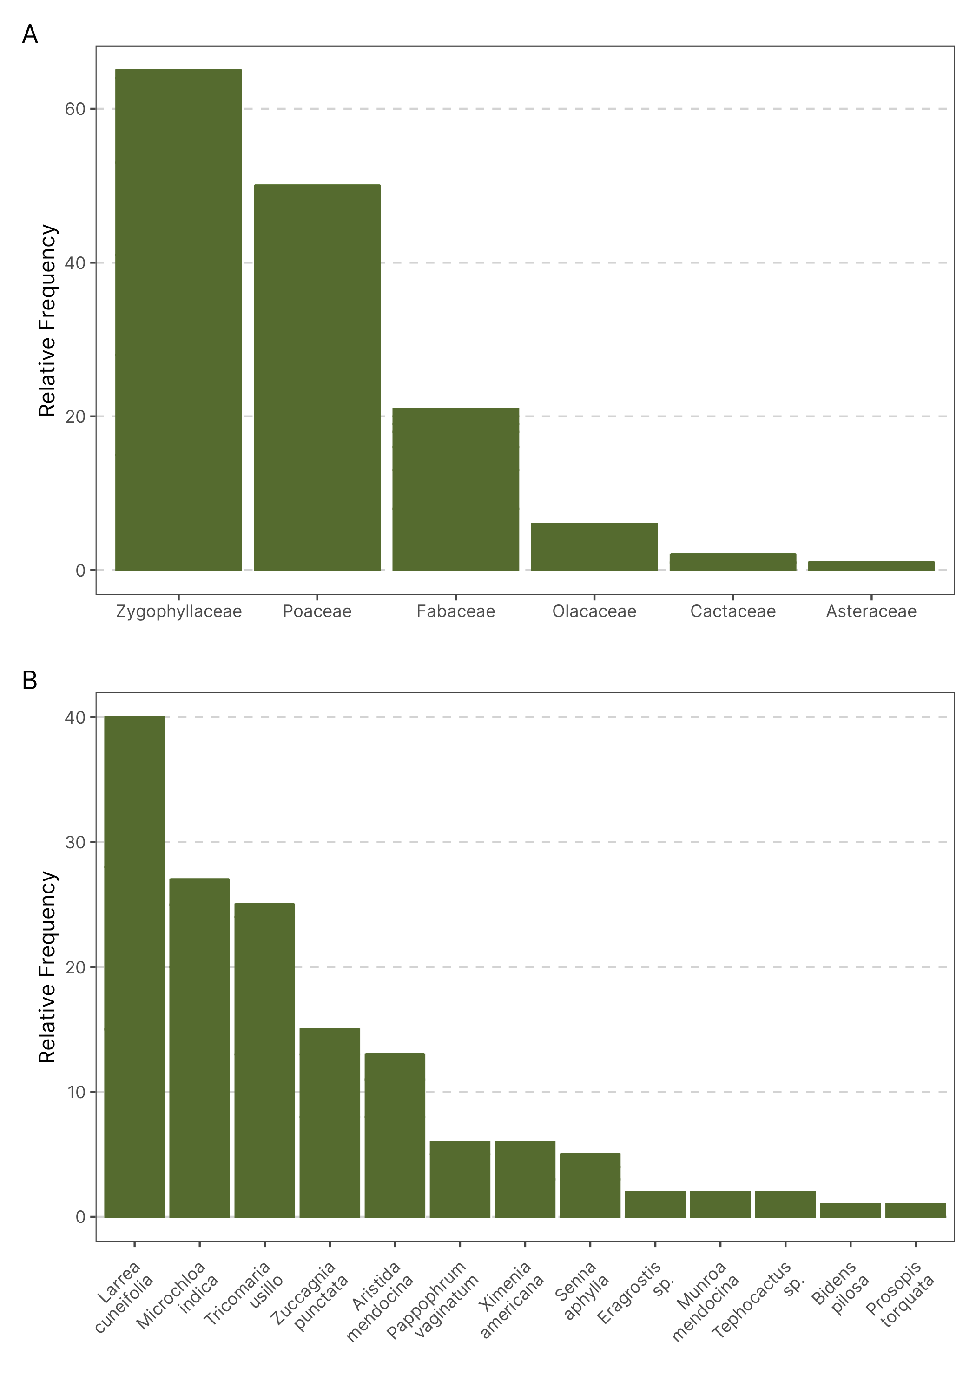

Figure 2.1: Relative frequency of plants family (A) and species (B) in three transects near the Study Site. The plant community is dominated by members of the Zygolhyllaceae, Poaceae and Fabaceae families and is in accordance with what has been described in the literature. (n = 145)

# 3 Anillaco’s Weather

include_graphics("../05_figures/weather/weather.png")

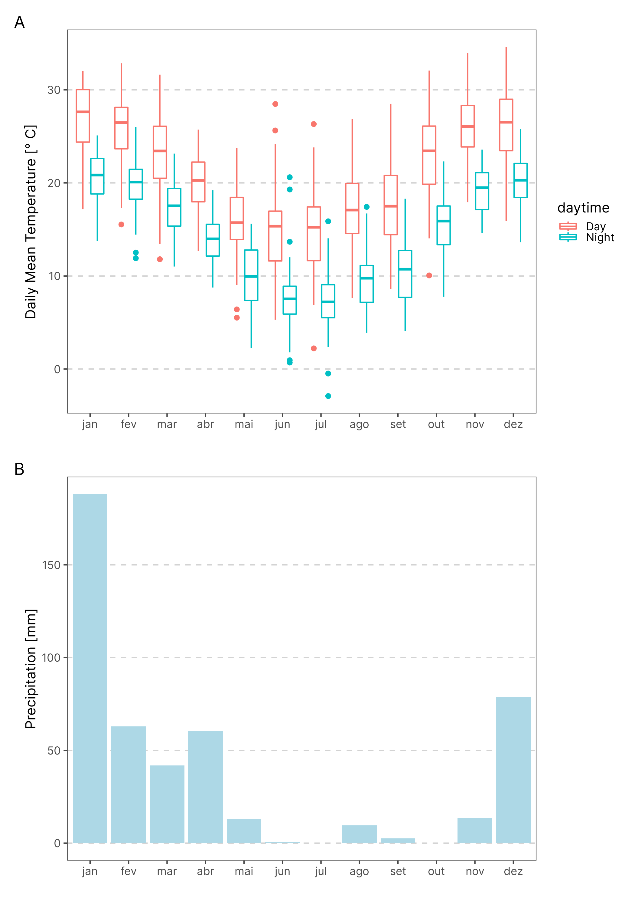

# References

Abraham, E., H. F. del Valle, F. Roig, L. Torres, J. O. Ares, F. Coronato, and R. Godagnone. 2009. “Overview of the Geography of the Monte Desert Biome (Argentina).” *Journal of Arid Environments* 73 (2): 144–53. <https://doi.org/10.1016/j.jaridenv.2008.09.028>.

Aranda-Rickert, Adriana, Patricia Diez, and Brigitte Marazzi. 2014. “Extrafloral Nectar Fuels Ant Life in Deserts.” *AoB PLANTS* 6 (January). <https://doi.org/10.1093/aobpla/plu068>.

Fracchia, S., L. Krapovickas, A. Aranda-Rickert, and V. S. Valentinuzzi. 2011. “Dispersal of Arbuscular Mycorrhizal Fungi and Dark Septate Endophytes by Ctenomys Cf. Knighti (Rodentia) in the Northern Monte Desert of Argentina.” *Journal of Arid Environments* 75 (11): 1016–23. <https://doi.org/10.1016/j.jaridenv.2011.04.034>.

Qasem, Lama, Antonia Cardew, Alexis Wilson, Iwan Griffiths, Lewis G. Halsey, Emily L. C. Shepard, Adrian C. Gleiss, and Rory Wilson. 2012. “Tri-Axial Dynamic Acceleration as a Proxy for Animal Energy Expenditure; Should We Be Summing Values or Calculating the Vector?” *PLOS ONE* 7 (2): e31187. <https://doi.org/10.1371/journal.pone.0031187>.

Shepard, Elc, Rp Wilson, Lg Halsey, F Quintana, A Gómez Laich, Ac Gleiss, N Liebsch, Ae Myers, and B Norman. 2008. “Derivation of Body Motion via Appropriate Smoothing of Acceleration Data.” *Aquatic Biology* 4 (December): 235–41. <https://doi.org/10.3354/ab00104>.